

HIGH LEVEL DESIGN (HLD)

Insurance Premium Prediction



#### Jay Telgote

iNeuron

# Document Version Control

|  |  |  |  |
| --- | --- | --- | --- |
| **Date Issued** | **Version** | **Description** | **Author** |
| **02.09.2023** | V1.0 | Initial HLD- V1.0 | Jay Telgote |

Contents

Document Version Control 1

Abstract 3

* 1. Introduction 3
  2. Why this High-Level Design Document? 3
  3. Scope 4
  4. Definitions 4
  5. General Description 5
  6. Product Perspective 5
  7. Problem Statement 5
  8. Proposed Solution 5
  9. Further Improvements 5
  10. Technical Requirements 6
  11. Data Requirements 6
  12. Tools Used 6
  13. Constraints 8
  14. Assumptions 8
  15. Design Details 8
  16. Process Flow 8
  17. Event Log 9
  18. Performance 9
  19. Reusability 9
  20. Application Compatibility 9
  21. Deployment 10

5.0 Dashboards 10

6.0 Conclusion 11

# Abstract

I analysed the personal health data to predict health insurance premium of individuals. Five regression models naming Linear Regression, Decision Tree Regression, Random Forest Regression, Gradient Boosting Regression, KNN have been used to compare and contrast the performance of these algorithms.

Training dataset was used for training model and that training model helped to come up with some predictions. Then the predicted amount was compared with actual data to test and verify the model accuracy. Later accuracies of all these models were compared. It was found that Gradient Boosting and Random Forest algorithms performed better than the remaining models.

Gradient boosting is best suited in this case because it gives best evaluation score compared to other models.

# Introduction

## Why this High-Level Design Document?

The purpose of this High-Level document is to add necessary details to current project description to represent a suitable model for coding. This document is used as a reference manual for how the model interact at a high-level.

4 High Level Design (HLD)

### The HLD will

* + - Presents all design aspects and define them in detail.
    - Describe the user interface being implemented.
    - Describe the hardware and software interfaces.
    - Describe the performance requirements.
    - Include design feature and the architecture of the project.

## Scope

The HLD document presents the structure of the system, such as the database architecture, application architecture, and technology architecture. The HLD uses non-technical to middle-technical terms which should be understandable to the administrators of the system.

## Definitions

**Term Description**

Database IDE API KPI

VS Code EDA

Collection of all the information

Integrated Development Environment Application Programming Interface Key Performance Indicator

Visual Studio Code Exploratory Data Analysis

* 1. General Description

## Product Perspective

The Health Insurance premium estimation is a machine learning based predictive model which will help us to predict the premium of the personal for health insurance.

## Problem Statement

To develop an API interface to predict the premium of insurance using people’s individual health data and analysing the following:

* + - To detect whether the BMI values affects the premium.
    - To detect whether the smoking affects the premium of the insurance.
    - To create API interface to predict the premium

## Proposed Solution

The solution proposed here is an estimating premium of insurance based on people’s health data and this can be implemented to perform above mentioned use cases. In first case, analysing how BMI value affects the people’s health as well as premium of the insurance. In the second case, if model detects that smoking is affecting the premium or not, we will inform that to people. And in the last use case, we will be making an interface to predict the premium.

* 1. Technical Requirements

The solution can be a cloud-based or application hosted on an internal server or even be hosted on a local machine. For accessing this application below are the minimum requirements:

* + - Good internet connection.
    - Web Browser.

For training model, the system requirements are as follows:

• +4 GB RAM preferred

* + - Operation System: Windows, Linux, Mac
    - Visual Studio Code / Jupyter notebook
  1. Data Requirements

Data requirements completely depends on our problem statement.

* + - Comma separated values (CSV) file.
    - Input file feature/field names and its sequence should be followed as per decided.
  1. Tools Used

Python programming language and frameworks such as NumPy, Pandas, Scikit-learn, Plotly, Streamlit are used to build the whole model.

  





* + - Pandas is an open-source Python package that is widely used for data analysis and machine learning tasks.
    - NumPy is most commonly used package for scientific computing in Python.
    - Plotly is an open-source data visualization library used to create interactive and quality charts/graphs.
    - Scikit-learn is used for a machine learning.
    - Streamlit is used to build an API.
    - VS Code is used as IDE (Integrated Development Environment)
    - GitHub is used as version control system.
    - Front end development is done using HTML/CSS.
    - Heroku is used for deployment of the model.
  1. Constraints

This model must be user friendly, as automated as possible and users should not be required to know any of the workings.

* 1. Assumptions

The main objective of the project is to develop an API to predict the premium for people on the basis of their health information. Machine learning based regression model is used for predicting above mentioned cases on the input data.

* 1. Design Details

## Process Flow

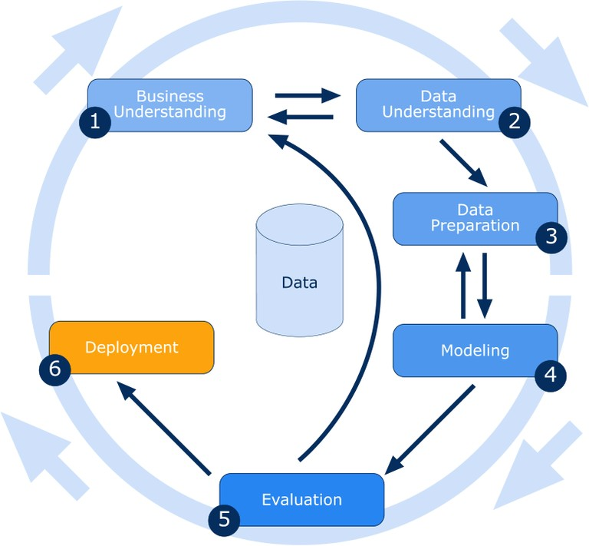

## Event Log

The system should log every event so that the user will know what process is running internally.

**Initial Step-By-Step Description:**

* + - The system identifies at what step logging required.
    - The system should be able to log each and every system flow.
    - Developer can choose logging method. You can choose database logging.

System should not hang out even after using so many loggings.

# Performance

## Reusability

The entire solution will be done in modular fashion and will be API oriented. So, in the case of the scaling the application, the components are completely reusable.

## Application Compatibility

The interaction with the application is done through the designed user interface, which the end user can access through any web browser.

## Deployment





# Dashboards

A dashboard is a data visualization and analysis tool that displays on one screen the status of key performance indicators (KPIs) and other important business metrics.



As a high-level reporting mechanism, dashboards provide fast ‘big picture’ answer to critical business questions and assist and benefit decision making in several ways:

* + - Communicating how premium is varies with BMI value.
    - Visualizing relationship of gender with premium in easy-to understand way.

6.0 Conclusion

This system shows us that the different techniques that are used in order to estimate the how much amount of premium required on the basis of individual health situation. After analysing it shows how a smoker and non-smokers are affecting the amount of premium. Also, significant differences between male and female expenses. Accuracy, which plays a key role in prediction-based system. From the results we could see that Gradient Boosting turned out to be best working model for this problem in terms of the accuracy. Our predictions help user to know how much amount premium they need on the basis of their current health situation.